**CHAPTER 4**

**RESULT 4.1 CIRCUIT CONNECTION:**

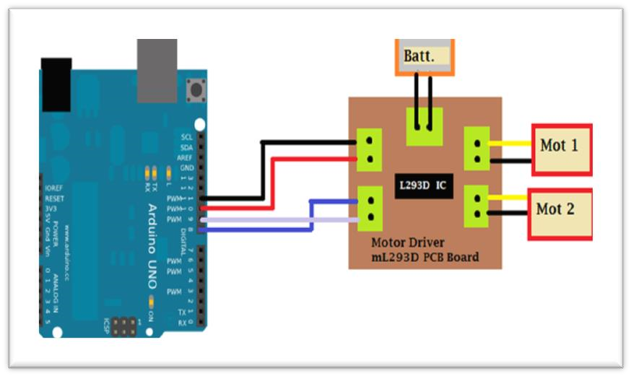

**FIGURE 4.1 :**  Interfacing of Arduino UNO with Motor driver

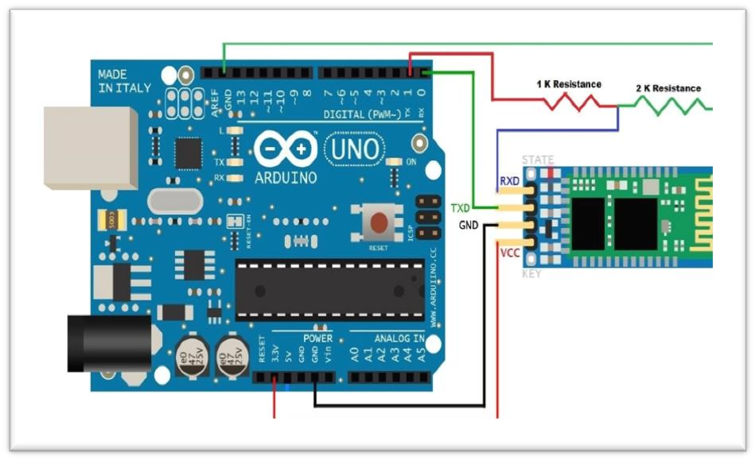

**FIGURE 4.2 :** Interfacing of Arduino UNO with Bluetooth

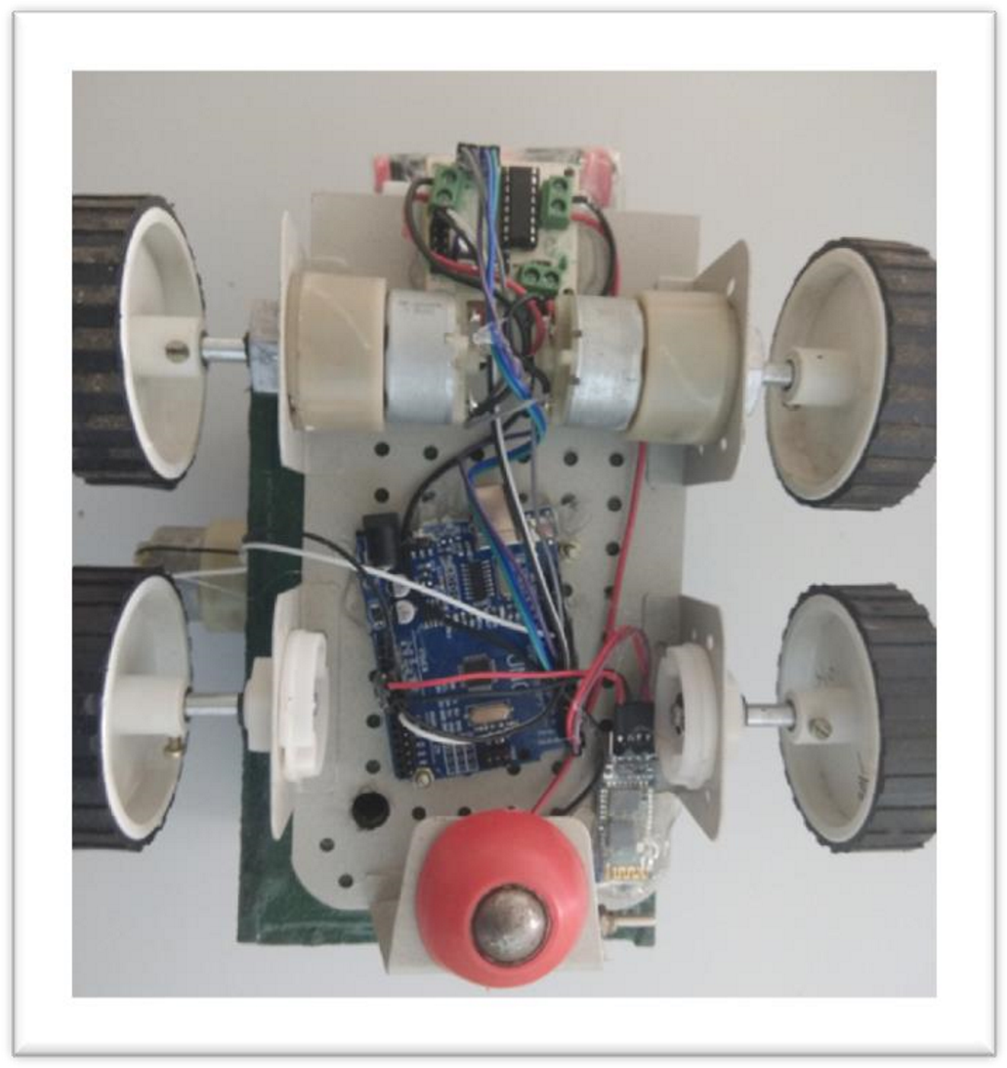

**FIGURE 4.3:**  Complete Interfacing of all the Components

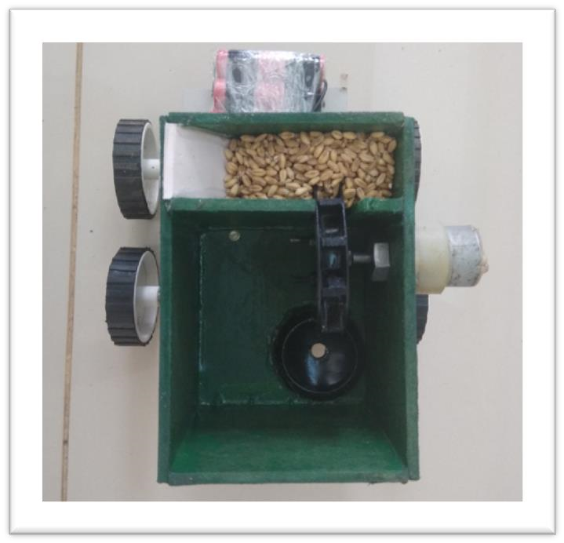

**FIGURE 4.4:** Top view

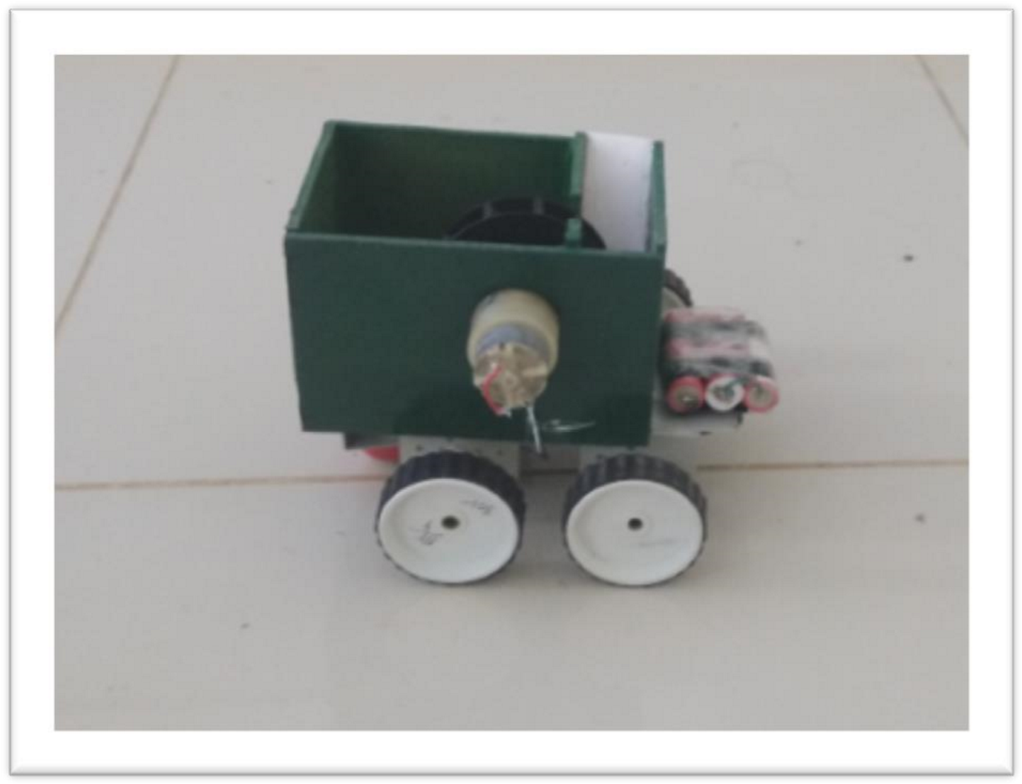

**FIGURE 4.5:**  Complete model